gorilla3d Java Videos

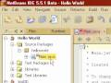3:11  Java 01: Hello World | 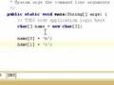  5:48  Java 02: Variables | 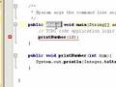5:06  Java 03: Functions | 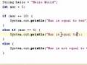7:52  Java 04: If & Switch Statements | 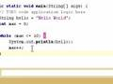3:11  Java 05: While & For Loops Statements
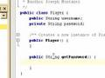6:39  Java 06: Basic Classes | 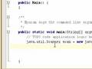3:41  Java 07: Namespace & User Input | 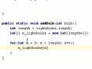9:20  Java 08: Advanced Arrays  31,605 views | 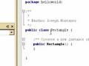  Java 09: Inheritence, Abstract Classes & Methods | 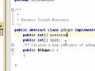5:13  Java 10: Interfaces

